Trigonometry and Modelling - Questions
June 2017 Mathematics Advanced Paper 1: Pure Mathematics 3

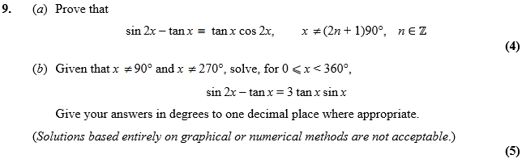

Jan 2013 Mathematics Advanced Paper 1: Pure Mathematics 3

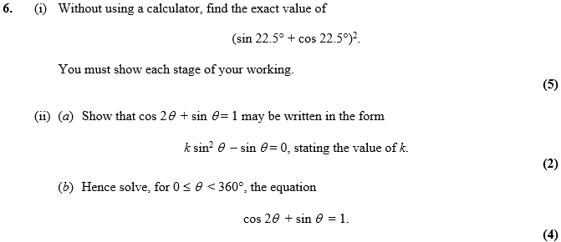

Jan 2012 Mathematics Advanced Paper 1: Pure Mathematics 3

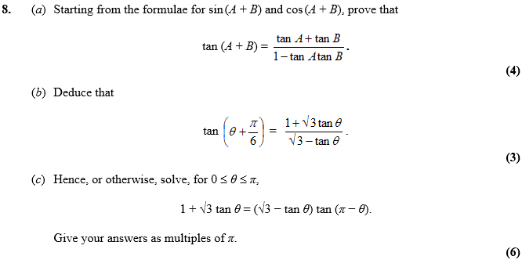

June 2011 Mathematics Advanced Paper 1: Pure Mathematics 3

